German invalids trained for battle

3rd June 1943: The Wehrmacht's insatiable demand for men means that thousands of injured have to be patched up and sent back to the front line
JUN 3

SHARE

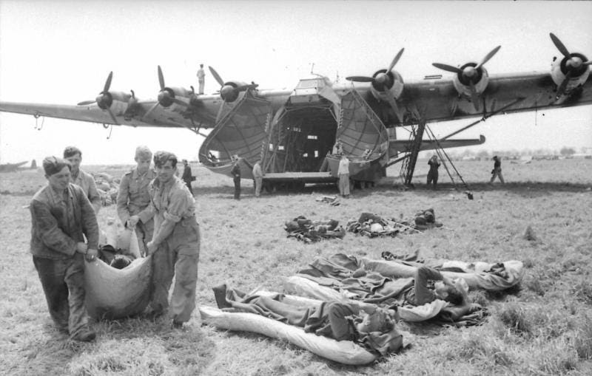
German wounded arrive back in Italy from North Africa in early 1943
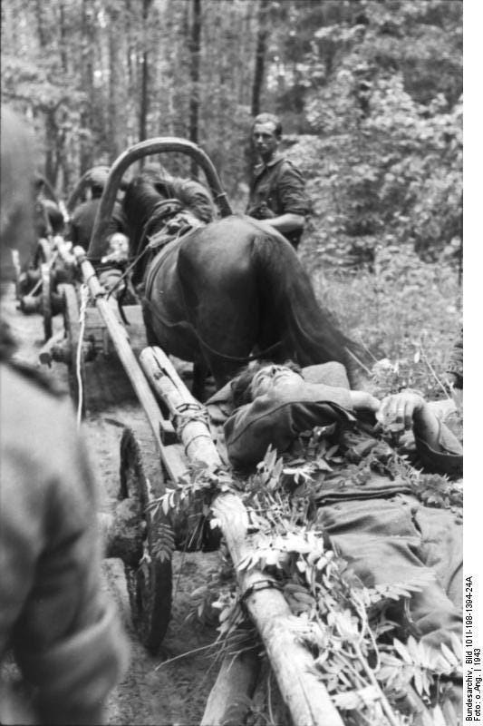
The evacuation of German wounded on the Eastern Front in 1943.
Oion Barbarossa and the following campaigns in Soviet Russia had resulted in far higher casualties than the Wehrmacht had ever contemplated. They had inflicted appalling losses on the Red Army but had suffered terribly themselves in doing so. This had been the case long before Stalingrad. But now they were engaged in a war of attrition as never before.
I wore the black Badge of the Wounded with some pride on my uniform jacket, but there were several squaddies among us who had already received the silver or even the golden Badge of the Wounded, signifying that they had been wounded on several occasions. This was no longer the young, healthy and dynamic gang as it was the year before prior to our first deployment.
The Wehrmacht needed men - and they were in limited supply. In Russia, some two million men came of age and went into military training yearly. In Germany, the numbers were far less. After enlarging the cohort eligible for conscription and reducing the number of protected occupations, they still needed men.
The troops who had had the ‘luck’ to suffer a 'Heimatschuss' earlier in the war were to discover that it was only a temporary reprieve.
Arno Sauer¹ had been extremely lucky to survive a serious wound to the thigh and a night lying out on the battlefield in late 1942. Now he was being prepared to be sent back:
Many of our comrades were half cripples, although the very severely wounded were no longer drafted to the reserves. Nevertheless, training and duty followed the usual strict military procedures.
I was accommodated there in a barrack with slightly and moderately injured soldiers, and here we effectively experienced our physical training anew and our reintegration into the Wehrmacht. My injury was classified as moderate with impaired mobility.
Almost every front division had such convalescent battalions at that time in which the convalescent soldiers were made fit for the next front deployment. After a pretty much complete recovery of their operational readiness, these soldiers were restored to the original units as reserves - as far as the latter still existed.
The daily routine ran a similar course to the one in the previous year at the Gneisenau barracks in Coblenz, except that all the participants in this bunch including the numerous instructors were already marked by war, sometimes more, sometimes less.
I wore the black Badge of the Wounded with some pride on my uniform jacket, but there were several squaddies among us who had already received the silver or even the golden Badge of the Wounded, signifying that they had been wounded on several occasions. This was no longer the young, healthy and dynamic gang as it was the year before prior to our first deployment.
Many of our comrades were half cripples, although the very severely wounded were no longer drafted to the reserves. Nevertheless, training and duty followed the usual strict military procedures. The more critical the situations became at the far-stretched fronts and through the continuous heavy bombing raids on the cities, the rougher and harsher the tone became in the barracks.
...
…. despite our handicaps the usual barrack duty was at any rate a thousand times more bearable than deployment at the front.
Far away from the front we heard here in sleepy Saarburg rather little of all the dramatic events and the escalating developments. Apart from a few incidents and despite our handicaps the usual barrack duty was at any rate a thousand times more bearable than deployment at the front.
One of these negative incidents was an argument with Senior Lieutenant Grossmann. The latter was perhaps not actually a fanatical firebrand, but in spite of his disability after an amputation of his forearm he was an especially ambitious instructor. When he chased us over the obstacle course in the grounds and I faltered at climbing over the two-metre high boarded wall due to my infirm leg, I received a loud and coarse admonition. However, my once so strong left take-off leg did not work as it had used to, and a quick run-up was only possible to a very limited and restricted extent.
Yet due to my front experience and my callousness gained in the meantime he did not achieve the desired intimidation with me. Athletically I would have easily put him in the shade, and so I replied coldly: ‘That your arm was amputated, Senior Lieutenant Sir, is immediately noticeable, my thigh injury in contrast is not.’
I limped leisurely around the obstacle and simply left the officer standing there. Sometime later he apologised to me in a private conversation, and with this the incident was forgotten.
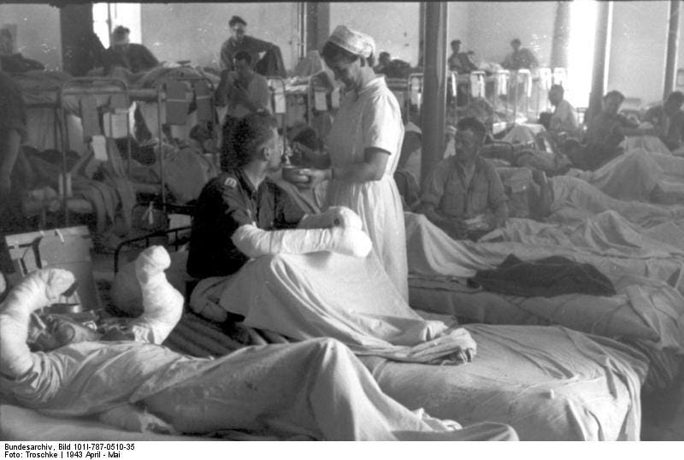
A German military hospital in North Africa in the Spring of 1943. If they were lucky these men would soon be taken prisoner and would not be forced to take part in the final battles.
1
In the Hell of the Eastern Front: The Fate of a Young Soldier During the Fighting in Russia in WW2

